Robo Rocks, Team 79

Engineering Notebook

Out from Sulphur Springs High School

Demo Daze Model: Miley

Coach : Matt Wilder

Email: jwilder@ssisd.net

Glossary

Vison Statement

Engineering Design Process

Safety Test

Robot

Design Process (A)

Base

Design Process (B)

Wheels

Skis

Motors

Scoop

Design Process (C)

Building

Arm

Design Process (D)

Building

Claw

Design Process (E)

Building

Coding

Final Product

Testing

Images

Vision Statement

We want to be the world’s leading brand in manufacturing environmentally conscious and adaptable robotics that anyone can use to achieve a variety of tasks assigned.

Examples of our past projects that helped environmentally were:

Our Ocean Cleaning Robot- which had picked up trash from trash sites in the ocean. This robot had also helped keep turtles and other marine life from getting caught in the trash.

Our Alternate Lineman Robot (AL)- which had been brought to help bring power back to populated areas. This robot fixed powerlines and brought generators to houses after the power goes down.

Our Biomedical Robot (Bob)- This robot had the ability to separate healthy cells, immune cells, and infected cells.

New Robot- Safe Construction Robot (Miley)- Helps with working through a construction site to minimize the tools needed.

We plan to continue our vision in manufacturing environmentally conscious and adaptable robots.

Engineering Design Process

Explore

Brainstorm. Choose the best idea. Make a plan.

Plan

What have others done? Explore options. Explore materials

What is the problem? What are the constraints? What’s the Criteria?

Ask

Create

Follow your plan and start building

Analyze your data. How can you make it better? Redesign

Improve

Design satisfies the goal. Present the design. Reflect

Try it out. Collect data. Record observations

Produce

Test

When coming up with the robot design we were given the game’s rules and what we needed to accomplish. After going over the rules for the game we set our priorities. The first priority would be to remove cement blocks to have more driving room. The second priority would be to demolish and put tower trash up or install light poles. The third priority would be to move the air compressor or bundle. To meet these priorities, we started brainstorming ideas for the robot we were going to make for the competition. Everybody was given a challenge to complete by the end of the week before we came back together to collaborate: Build your own model of a robot that would have the components to meet our wants. At the end of the week, we came together and decided on the best combinations of ideas. We took these ideas and made them apart of the robot’s design:

A Scoop- To help pick up the heavier items. A smaller square base- Allow for less chances to run into things in the site. Arm- meant to help pick up items to place them into their correct places. Claw- to clamp down on any shape size item and can help place things accurately. Also, we want to be able to do the autonomous challenge.

Safety Test

To Robo Rocks safety is very important so we make sure that all of our members have a good understanding and practice safety measures every day. Within our company we have everyone test out on all tools that we have available. Results of our test are below.

|  |  |  |  |  |  |
| --- | --- | --- | --- | --- | --- |
| Names | Hand Tools | General Safety | Drill Press | Belt Sander | 3D Printer |
| Marco (12) | 100 | 100 | 100 | 100 | 100 |
| Fabian (12) | 100 | 100 | 100 | 100 | 100 |
| Jimmy (11) | 100 | 100 | 100 | 100 | 100 |
| Isabelle (11) | 100 | 100 | 100 | 100 | 100 |
| Geronimo (11) | 100 | 100 | 100 | 100 | 100 |
| Kobe (11) | 100 | 100 | 100 | 100 | 100 |
| River (12) | 100 | 100 | 100 | 100 | 100 |
| Aiden (9) | 100 | 100 | 100 | 100 | 100 |
| Matthew (10) | 100 | 100 | 100 | 100 | 100 |

After the safety test we divided our classes into teams that will help cover all areas of the competition, Booth, Marketing, Engineering, Programing, and Notebook.

Booth- Marco, Fabian (Leader), G-Mo, Aiden, Matthew

Marketing- Marco, Fabian (Leader), Isabelle, G-Mo, Jimmy

Engineering- Isabelle (Leader), Jimmy

Programing- Kobe (Leader)

Notebook- Isabelle, River, Fabian, Kobe, G-Mo

Robot

Design Process (A)

With the design of our robot, we took into consideration of the scoring of the game. We knew we wanted the robot to be able to score the most points possible. We could see that we would need a robot that could pick up and move debris while being able to place down light poles and fence. To meet these parameters, we know that a small to mid-size robot. Have an arm and claw that can pick up items of various sizes. Have a scoop that can help move the heavier objects longer distances.

Base

Design Process (B)

Further into the design of the base of our robot, we needed to make a base that was small enough to navigate a construction site but big enough to be able to hold the weight of the debris of the site.

Wheels

* To keep the size of the wheels complementing the size of the base we decided to make the wheels smaller. And we also decided to only have two wheels that would be placed in the middle of the base as to save space. We decided against having four wheels having each sides wheels connected with a track or treads because of turning problems. When we tested the wheels on carpet, we saw that there were multiple times where the wheels had slipped. To fix this slipping we drilled holes on the edges of the wheels so then when the wheel turned it had something to help grip the ground, so our wheels stay moving.

Skis

* We employed the use of skis to the base so then we could have a level base to help counterweight of the scoop and arm. To make the skis we used PVC pipes and elbows. We added two skis one for front and back. h

Motors

Two large motors for the wheels.

Measurements

-Base- The final size chosen was 12x10 inches with the 12 inches being the length of our robot and the 10 inches be the width of our base.

-Wheels- Diameter of 5 inches and a radius of 2 ½ inches. The holes drilled into the edges of the wheels are ½ inches apart and have a size of a 5/8th bit.

-Skis- The Skis were made to be match the height of the base with the wheels. The PVC was cut to a length of 6 inches and was marked off at 1 inch for heat to be applied for it to be bent. We bent it at an angle 30°.

Scoop

Design Process (C)

For the scoop we want it to be able to pick up any objects that lie in the path of the robot. Knowing this we had to decide between using servos or a small motor to help move the scoop. We choose to use a motor to help support the weight of any objects. To connect the scoop to the motor we had noticed that the motor would need to be placed near middle of the bases back. Once we got the motor in its place, we cut an “arm” that will connect to the scoop and the motor. This “arm” was glued into a hole that was cut into the piece of wood that connected the scoop. This piece of wood was used to add stability to the scoop while it is in use. To fully connect the scoop to the motors we placed a belt driver with a bar to hold the “arm” in place when the motor turns. The arm is held in place on the bar by a nut. We put a belt on the driver and connected it to the scoop in two places. One at the top on the wood and at the bottom in line with the one on the wood. To keep tension in the belt we tied a string around it.

Building/Measurements

We had cut the scoop to be 12 inches wide by 5 ½ inches long. The scoop was bent in 3 places the first at 1.5 inches from the bottom of the scoop, the second 1.8 inches from the bend, and the third is 2.7 inches from the second bend. The motor was placed at 4.5 inches from the edge of the base. The arm of the scoop is two wood pieces 1 inch by 4 inches glued together with wood glue. The hole that we added to allow the arm of the scoop to move is 3.4 inches and from cut to cut is 3.4 inches. The wood bar that is connected to the scoop is 1 inch by 12 inches. This is connected to the scoop by two bolts that are both placed 1 inch in on both sides of the top of the scoop. The bar has a length of 3 inches.

Arm

Design Process (D)

For the arm we wanted it to be able to help give us the reach the higher/farther locations that the scoop could not get to. To reach this goal we designed the arm to be off of the base by stands and have two limbs that will be connected by two bars (one o both ends). While making the arm components we decided that we would need to power the arm with a motor over a servo because the servos only have 180° of motion while the motor will have 360° and we will need the extra range of motion. To add support to the limbs when picking up supplies we added two beams instead of one to the limbs. The beams were glued together by wood glue to make the limbs. After consideration we decided to add two more limbs (one to each of preexisting limbs) to add to the length of the arm and to give us the ability to pick up supplies out of the scoop. Bringing the total of limbs to four and threaded bars to three. Each of the nuts used to hold the limbs in place on the bar have electrical tape underneath them so that we can lessen the number of times that we have to tighten them at the competition. We had changed the electrical tape out on both far ends of the arm for epoxy and left the middle with electrical tape to keep the nuts super secure.

Building

The stands that held the arm up over the base were two different sizes because we just wanted the threaded bar to be even with the motor. The motor’s stand was 2.5 inches high by 5 inches long of wood. The stand for the bar itself was 2.5 inches wide by 4 inches high of wood. The beams are 1.5 inches by 7 inches of plywood. Each Limb has two bars. The threaded bars that connected the limbs were 5 ½ inches in length.

Claw

Design Process (E)

For the claw we knew that we would want it to be able to grab objects of all sizes and weights. To do this we knew that we would have to 3-D print our parts to make the claw exactly how we wanted it. We have chosen to make a claw that has finger like pieces that can wrap around the items like a person would with their hands. To connect the claw to the arm and make it functional we are using the servos which are attached on the end part of the arm. We are using two servos one for each side of the claw to help give us that extra space to allow us to get around the items.

Coding

We coded in EasyC, the program uses 3 control components. Arcade2 has parameters for motor and button control. In the parenthesis are numbers signifying which motor is controlled by each button press on the controller. JoystickDigitalToMotor are the other two control components the values shown in the parenthesis control which motor is controlled by which button press and how fast they move forward and backwards.

Final Product

Testing

Before we began testing our robot, we came up with a possible plan of how we were going to go about the game field.

* Our first thing to hit on the field was to clear the concrete blocks.
* After the blocks we were going to try the autonomous portion of game.
* We would place fence around the back side of the field to help contain the debris from the tower.
* We would then Knock down the tower and put the destructed items in their proper spots.
* The last thing we would do was place the light poles.

Once we got the base together (meaning wheels, skis, and brain) we started test driving around the game field to get an idea if we needed to change anything that we had so far. During our first testing stages we noticed a lot of slipping in the wheels. We took these things into consideration and made changes listed in Design Process (B). Once we fixed the wheels slipping problem, we were able to test the movements of our plan for the competition.

Images

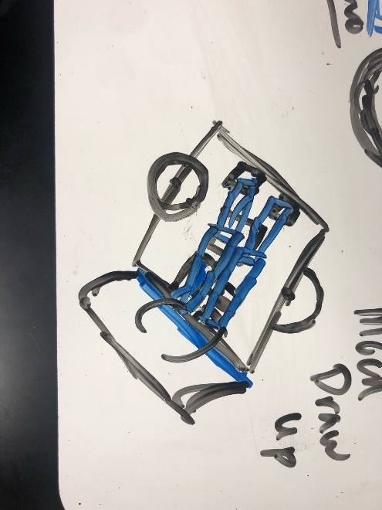These are pictures of what we wanted our robot to look like while we were designing it.

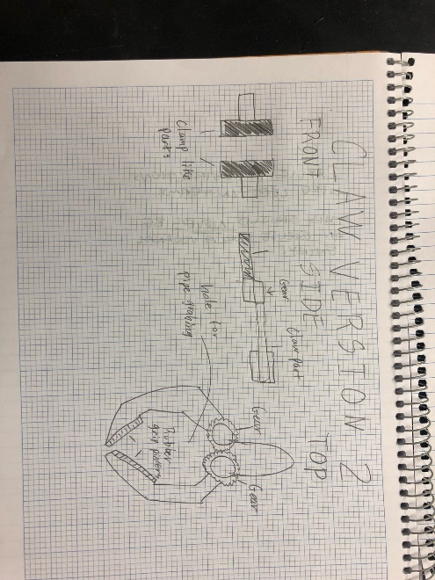

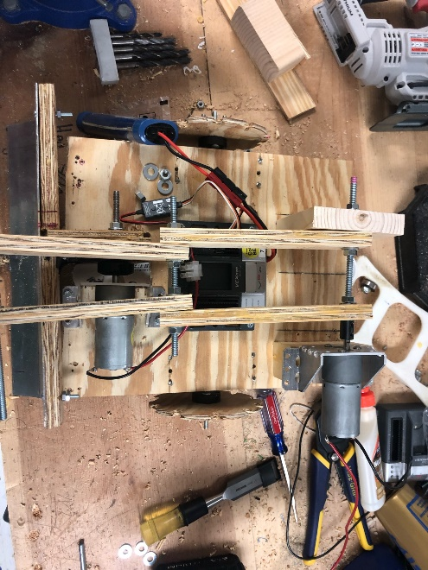

These are pictures of our robot without the claw.

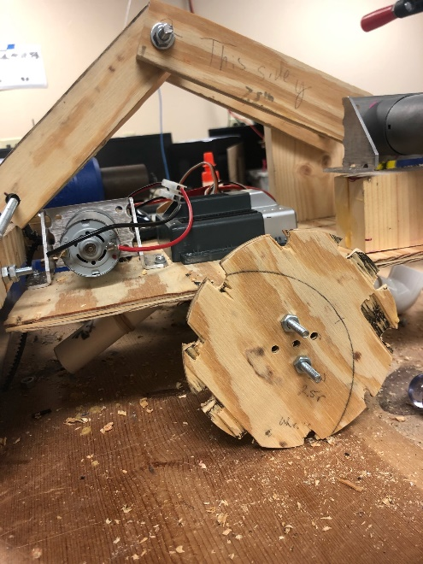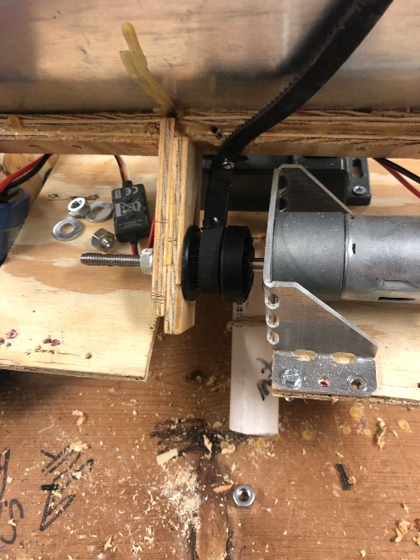These are pictures of the scoop and its setup.

